Document Prepared by: - Soham Parekh

* Questions
  + What Happens when user searches for the job?
  + What all Additional Search Features you would like to have in search?
  + As you have Described in your entities, on what basis the search will take place i.e. on what entities user will be able to search for Job.
  + How much scalable you want your search product, when multiple users search?
  + What is the Role of Agents according to the entities?
  + What all things would you like to display when anyone access the search and user get the result?
  + Would you like to het the results based on your Profile?
  + Which type of layout you want for search and to display results?
  + When User gets the Result, which type of Layout you want to show it to the end user?
  + If Someone enter the Co-Ordinates then many Jobs can be found in that location, so you want to display all the Job list or if end user enters Co-Ordinates, then user gets another field to search by Job Title, for that Co-Ordinate.
  + When User click on the job what all details you want to display for that job.
  + Would you like user to apply for that job or user can mail his/her Resume direct to the HR?
  + What functionality you want to add in you search when search does not match, what user searches.
  + Where is the data located, which is to be displayed when the user performs search task?
  + Should jobs be recommended to user according to his/her profile?
  + Which all Device you want to support this Search?
  + Should search be Responsive?
  + In which platform you want to support this universal search?
* Assumptions
  + According to our Assumptions and as it is a Job Search, we will set the Search bar in Job options, when user click the job button search bar will be displayed to user and list of jobs will be displayed according to the search.
  + UI will be User Friendly.
  + We will design it like when user search for the Job Title, Job related to that will be displayed and when user search by co-ordinates, Job Title also will be asked as an option so that for the specific location user can get the job which user wants.
  + When user checks for the details for that job, Job title with the Description will be displayed and Location of the Job.
  + According to User Profile, jobs will be recommended to the user
  + Apply button will be provided to apply for that job after that according to the user mail id, user will be contacted for the further process.
  + Jobs which are new will be displayed First according to UpdatedDateTime entity
  + Everything we develop will be develop will be delivered after being tested.
  + Every minor thing will be tested by our testing team and then only we will deploy the functionality to the product
* Mockups
  + Design

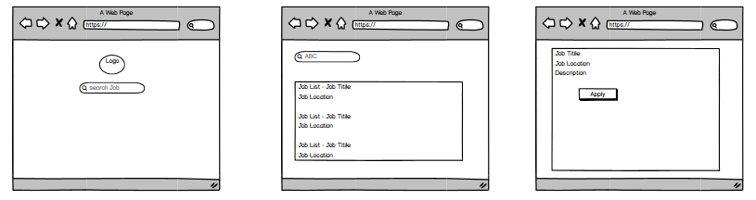

* + Process Flow Diagram

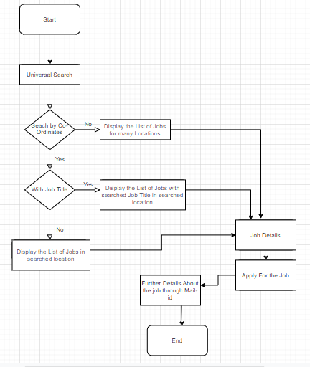

* Estimation
  + Goal: - Create and deploy Universal Search in the existing Product.
  + Priorities: -
    - Create Search Bar.
    - Connect to the Job Database.
    - Fetch Job according to Job title/Co-Ordinates.
    - Fetch & Display the Details of Job from the existing Product.
    - Detailed description for the Selected Job.
    - User Can Apply for the Job.
  + Functional Requirements: -
    - Develop a Universal Search
    - According to our Research product functionality needs to be developed similar to the job search like LinkedIn.
  + Non-Functional requirements: -
    - The System must respond with a latency of less than 3 seconds.
    - The system is scalable.
    - System is Secured.
  + According to the Expert Judgement this functionality might take maximum up to 2 Sprints (1 Sprint = 30 Days)
  + Estimation Based on Software Team – 1 to 1.5 Months